Laboratory Record
submitted as part of
Programming for Data Science Lab
(MACSE502)
LAB ASSESSMENT-9

by

To

Dr M Rajasekhara Babu

School of Computer Science and Engineering
October 2026

2026 FALL SEMESTER
Programming for Data Science Lab (MACSE502) Record
INDEX
Week No | Date | Sl. No. | Type | Topic | Title with download Link for document | Problem Statement | Page No.
1 | 09-07-2026 | 1 | PP | Pandas | Basic Data Manipulation with Pandas | Create a DataFrame with columns  Name, Age, and City containing data for five individuals. Perform the following operations: select only the Name and Age columns, filter rows where Age is greater than 25, add a new column Country with a default value, and sort the DataFrame by Age in descending order. Finally, calculate the average age of the individuals. | 1
1 | 09-07-2026 | 2 | EP | Pandas | AI Model Performance Analysis Using Pandas | An AI company maintains model performance records containing:  • ModelID  • Accuracy  • Algorithm  Perform:  1. Select ModelID and Accuracy.  2. Filter models with Accuracy greater than 90%.  3. Add Status with default value "Production Ready".  4. Sort models by Accuracy.  5. Calculate average model accuracy. | 6
2 | 16-07-2026 | 3 | PP | Pandas | Data Cleaning and Preprocessing with Pandas | Create a DataFrame with some missing values in columns Name, Age, and City. Perform the following operations: fill missing values in the Age column with the mean age, drop rows where Name or City is missing, and convert the Age column to integer type. Finally, normalize the Age column using min-max scaling | 14
2 | 16-07-2026 | 4 | EP | Pandas | Movie Rating Data Preprocessing Using Pandas | A streaming platform maintains movie records containing:  • MovieID  • Rating  • Genre  Perform:  1. Create a dataset with missing values.  2. Fill missing Rating values using average rating.  3. Remove rows with missing MovieID or Genre.  4. Convert Rating into integer type.  Normalize rating values. | 18
3 | 23-07-2026 | 5 | PP | NumPy | Creating and Manipulating Arrays Using NumPy | Create a 2D array of shape (3, 4) with random integers between 0 and 10. Perform the following operations: calculate the mean and standard deviation of the entire array, slice the array to get the first two rows and last two columns, reshape the array to shape (4, 3), and perform element-wise multiplication with another array of the same shape. | 30
3 | 23-07-2026 | 6 | EP | NumPy | Warehouse Shipment and Logistic Analytics Using NumPy | A logistics company tracks shipments from 4 warehouses across 7 weeks. Create a 4 x 7 shipment matrix. Perform: (1) compute average shipments, (2) compute standard deviation, (3) slice the first two warehouses and last three weeks, (4) reshape the matrix into a 7 x 4 matrix, and (5) perform element-wise multiplication with a transportation-cost matrix of the same shape. | 35
4 | 30-07-2026 | 7 | PP | Pandas  NumPy  Matplotlib | Feature Engineering and Exploratory Data Analysis | Feature Engineering, Exploratory Data Analysis: Create a DataFrame with columns Feature1, Feature2, and Target containing random data. Perform the following operations: create a new feature that is the logarithm of Feature1, bin Feature2 into three categories (low, medium, high), and calculate the correlation matrix of the DataFrame. Finally, create a scatter plot of Feature1 vs. Feature2 colored by Target, and interpret any visible patterns | 46
4 | 30-07-2026 | 8 | EP | Pandas  NumPy  Matplotlib | Employee Attrition Prediction Using Workforce Indicators | A company wants to analyze workforce behavior and predict employee attrition. Create a DataFrame containing: OvertimeHours JobSatisfactionScore SalaryLevel TrainingHours WorkLifeBalance YearsAtCompany PromotionCount AttritionStatus  Perform:  1. Create Log_OvertimeHours.  2. Categorize JobSatisfactionScore into: Disengaged, Satisfied, Highly Engaged.  3. Generate correlation matrix.  4. Create a Treemap Visualization of employee categories.  5. Analyze workforce trends. | 54
5 | 06-08-2026 | 9 | PP | Web Scraping | Web Scraping and Data Collection | Scrape data from a webpage and store it in a structured format like CSV orJSON | 63
5 | 06-08-2026 | 10 | EP | Web Scraping | Online Job Market Analytics | A recruitment agency wants to analyze job opportunities posted on a dynamic job portal. Develop a Python application using Selenium to scrape job listings, extract Job Title, Company Name, Location and Salary (if available), store the collected data in a Pandas DataFrame, save the dataset as a CSV file, and visualize job demand by location. | 70
6 | 20-08-2026 | 11 | PP | Plotly | Interactive Bar Chart with Plotly | Create an interactive bar chart showing the population of different cities | 80
6 | 20-08-2026 | 12 | PP | Plotly | Interactive Scatter Plot with Plotly | Create an interactive scatter plot showing the relationship between house size and price | 88
7 | 27-08-2026 | 13 | PP | Bokeh | Interactive Scatter Plot with Bokeh | Create an interactive scatter plot showing the relationship between petal length and petal width from the Iris dataset using Bokeh | 101
7 | 27-08-2026 | 14 | EP | Bokeh | Interactive Line Plot with Bokeh | Create an interactive line plot showing the  daily temperatures over a week using Bokeh. | 105
7 | 27-08-2026 | 15 | EP | Bokeh | Interactive Bar Chart with Bokeh | Create an interactive  bar chart showing the sales figures of different products using Bokeh | 109
8 | 03-09-2026 | 16 | PP | scikit-learn and Plotly | Visualizing Clusters with scikit-learn and Plotly | Perform Principal Component Analysis (PCA) on the Iris dataset and visualize the first  two principal components using an interactive 2D scatter plot in Plotly | 113
8 | 03-09-2026 | 17 | EP | scikit-learn and Plotly | Visualizing Clusters with scikit-learn and Plotly | Perform K-means clustering on the Iris dataset and visualize the clusters using an interactive 3D scatter plot in Plotly | 122
9 | 10-09-2026 | 18 | EP | arrays in Scala | arrays in Scala | Create an array of integers with the values 2, 5, 9, 14, 20. Write a function that takes this array and returns the sum of its elements. Next, create an array of strings with the names of five different fruits. Write a function that concatenates all elements of this array, separated by commas. Finally, iterate over the array of integers and print each element to the console | 131
10 | 17-09-2026 | 19 | EP | lists, sets, and tuples in Scala | lists, sets, and tuples in Scala | Create a list of the first five prime numbers. Write a function that takes this list and returns a new list with each element squared. Then, create a set of unique characters from the string "hello world" and write a function that takes two sets and returns their intersection. Create a tuple with three elements: an integer, a string, and a boolean, then access and print each element | 134
11 | 24-09-2026 | 20 | EP | HashMap’s | Handling collisions and resolving conflicts in HashMap’s | Create a HashMap with keys representing student names and values representing their grades, then insert multiple entries including a duplicate key with a different grade. Write a function to merge two HashMap’s, resolving conflicts by taking the higher grade. Finally, write a function to handle collisions by chaining, using lists to store multiple values for a single key. | 137
12 | 08-10-2026 | 21 | EP | Exploring advanced functional combinators beyond the basic set | Exploring advanced functional combinators beyond the basic set | Create a list of integers from 1 to 10, then use filter to create a new list with only even numbers. Use map to create a new list where each element is multiplied by 3. Use flatMap to create a list of tuples where each integer is paired with its square. Finally, use foldLeft to calculate the product of all elements in the list. | 140
PP: Practice Program; EP: Exercise Program; CP: Challenging Program

Title | Arrays in Scala
Problem Statement | Create an array of integers with the values 2, 5, 9, 14, 20. Write a function that takes this array and returns the sum of its elements. Next, create an array of strings with the names of five different fruits. Write a function that concatenates all elements of this array, separated by commas. Finally, iterate over the array of integers and print each element to the console.
Objectives | • To declare and initialize fixed-size arrays in Scala.  • To write a user-defined function that aggregates an integer array.  • To write a user-defined function that joins a string array.  • To traverse an array with an index loop and print every element.  • To verify a computed aggregate against an independent calculation.
Dataset URL Link / File | No external dataset is required. The inputs are declared inside the program: the integer array (2, 5, 9, 14, 20) and the string array (Apple, Banana, Mango, Grapes, Orange).
Functions Details | Sl. No. | Function | Package | Description of function
Functions Details | 1 | Array() | Scala | Creates a fixed-size array from the supplied elements.
Functions Details | 2 | sum | Scala | Returns the total of all elements of a numeric array.
Functions Details | 3 | mkString() | Scala | Joins every element into one string using a separator.
Functions Details | 4 | length | Scala | Returns the number of elements stored in the array.
Functions Details | 5 | apply(index) | Scala | Returns the element stored at the given index.
Functions Details | 6 | Array[Int] | Scala | Declares an array whose elements are integers.
Functions Details | 7 | Array[String] | Scala | Declares an array whose elements are strings.
Functions Details | 8 | def | Scala | Declares the user-defined functions used by the program.
Functions Details | 9 | while | Scala | Repeats the traversal while the index is below the length.
Functions Details | 10 | println() | Scala | Writes one formatted line of text to the console.
Functions Details | 11 | == (equality) | Scala | Compares the manual sum with the function result.
Functions Details | 12 | main() | Scala | Entry point that executes the program.
Steps/ Process/ Procedure/ Algorithm/ Flowchart/ Model | 1. Declare the integer array with the values 2, 5, 9, 14 and 20.  2. Define sumOfArray() that returns the total of the array elements.  3. Print the integer array, its length and the computed sum.  4. Declare the string array containing the names of five fruits.  5. Define concatenateStrings() that joins the elements using mkString.  6. Define printElements() that walks the array with an index loop.  7. Call printElements() so every integer is printed with its index.  8. Compute the sum manually and compare it with the function result.  9. Print the verification line and terminate the program.
Program | // Program 18 - Arrays in Scala  // Week 9 | 10-09-2026 | Exercise Program  object Program18 {  // (a) Function that returns the sum of all elements of an integer array  def sumOfArray(numbers: Array[Int]): Int = numbers.sum  // (b) Function that concatenates all elements of a string array, separated by commas  def concatenateStrings(names: Array[String]): String = names.mkString(", ")  // (c) Function that prints every element of an integer array  def printElements(numbers: Array[Int]): Unit = {  var index = 0  while (index < numbers.length) {  println(" Element at index " + index + " = " + numbers(index))  index += 1  }  }  def main(args: Array[String]): Unit = {  println("=" * 62)  println("PROGRAM 18 : ARRAYS IN SCALA")  println("=" * 62)  val numbers = Array(2, 5, 9, 14, 20)  println("\n1. Integer array : " + numbers.mkString("[", ", ", "]"))  println(" Length : " + numbers.length)  println(" Sum of all elements : " + sumOfArray(numbers))  val fruits = Array("Apple", "Banana", "Mango", "Grapes", "Orange")  println("\n2. String array (fruits) : " + fruits.mkString("[", ", ", "]"))  println(" Concatenated : " + concatenateStrings(fruits))  println("\n3. Iterating over the integer array:")  printElements(numbers)  val manualSum = 2 + 5 + 9 + 14 + 20  println("\n4. Verification : manual sum = " + manualSum +  " , function sum = " + sumOfArray(numbers) +  " , match = " + (manualSum == sumOfArray(numbers)))  println("=" * 62)  }  }
Output Snapshots With Explanation/ Observations | 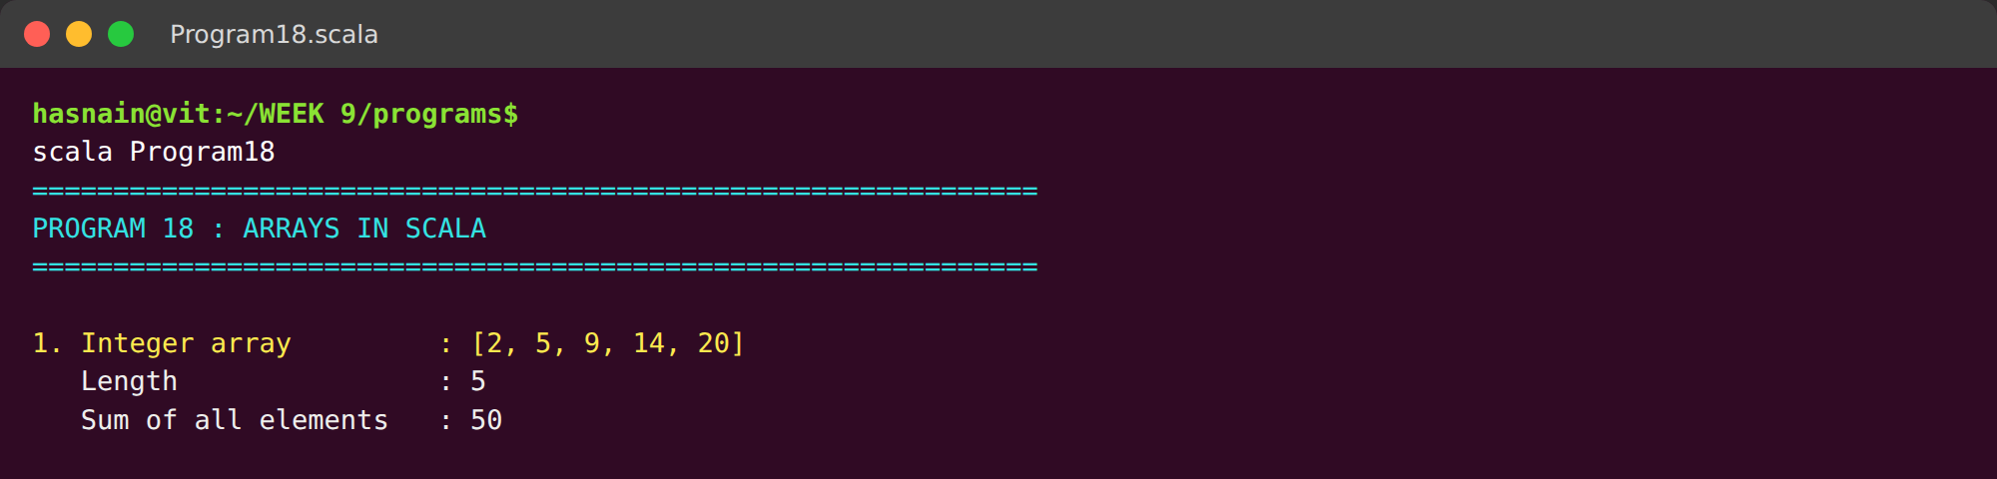  Fig. 1.1: Terminal execution showing creation of the integer array, its length and the sum returned by the user-defined function. The string array is concatenated using mkString().  The integer array is printed first with its length, and the user-defined function returns the sum 50, which the next line confirms against the manually calculated value. The string array is joined with mkString so the five fruit names appear as one comma-separated line.
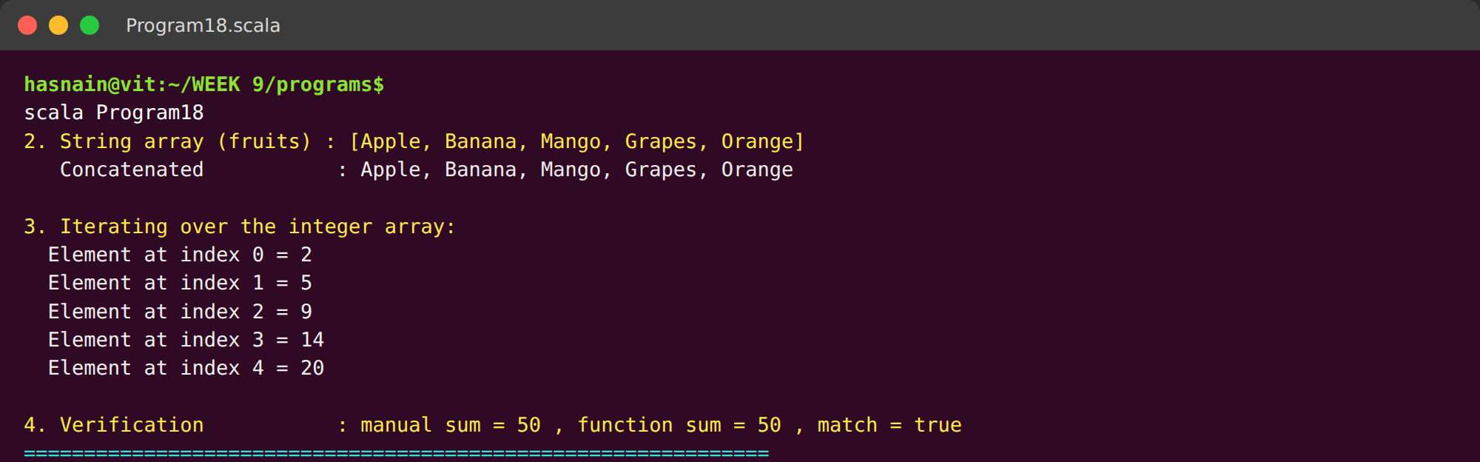
Fig. 1.2: Index-based traversal printing every element of the integer array, followed by the verification line confirming that the function result matches the manual sum.
The index loop walks the array from position 0 to 4 and prints each element beside its index, which shows that a Scala array is addressable by position. The final verification line reports that the manual sum and the function result are equal.
Conclusions | The integer array (2, 5, 9, 14, 20) was created successfully and the user-defined function returned a total of 50, which matched the manually calculated value. The string array of five fruits was concatenated into a single comma-separated string using mkString(). The index-based traversal printed every element of the integer array together with its position. The experiment demonstrated that Scala arrays are fixed-size, index-addressable collections and that aggregation and string joining can be expressed concisely through built-in collection methods.
References | 1. Scala Array documentation: https://www.scala-lang.org/api/current/scala/Array.html  2. Scala Collections overview: https://docs.scala-lang.org/overviews/collections/overview.html  3. Class lecture: Arrays and array operations in Scala.  4. Python program (GitHub link): https://github.com/hasnainmakada-99/Data-Science-Codes/blob/main/WEEK%209/programs/Program18_Arrays.scala

Title | Lists, Sets and Tuples in Scala
Problem Statement | Create a list of the first five prime numbers. Write a function that takes this list and returns a new list with each element squared. Then, create a set of unique characters from the string hello world and write a function that takes two sets and returns their intersection. Create a tuple with three elements: an integer, a string and a boolean, then access and print each element.
Objectives | • To create immutable lists and transform their elements with a function.  • To build a set of unique characters from a string.  • To compute the intersection of two sets.  • To construct a tuple holding three different types and access its components.  • To compare immutable collections with the arrays used earlier.
Dataset URL Link / File | No external dataset is required. The inputs are the first five prime numbers (2, 3, 5, 7, 11), the literal string hello world and the tuple (101, Hasnain Makada, true).
Functions Details | Sl. No. | Function | Package | Description of function
Functions Details | 1 | List() | Scala | Creates an immutable linked list of elements.
Functions Details | 2 | map() | Scala | Applies a function to every element, returning a new list.
Functions Details | 3 | sum | Scala | Returns the total of all elements of a numeric list.
Functions Details | 4 | toSet | Scala | Converts a string or collection into a set of unique values.
Functions Details | 5 | Set() | Scala | Creates an immutable set that rejects duplicates.
Functions Details | 6 | intersect() | Scala | Returns the elements common to two sets.
Functions Details | 7 | size | Scala | Returns the number of elements in a set or list.
Functions Details | 8 | toList | Scala | Converts a set into a list so that it can be sorted.
Functions Details | 9 | sorted | Scala | Orders the elements of a collection in ascending order.
Functions Details | 10 | Tuple3 / ( ) | Scala | Creates a tuple grouping three values of mixed types.
Functions Details | 11 | _1, _2, _3 | Scala | Accesses the first, second and third tuple components.
Functions Details | 12 | println() | Scala | Writes one formatted line of text to the console.
Steps/ Process/ Procedure/ Algorithm/ Flowchart/ Model | 1. Create the list of the first five prime numbers 2, 3, 5, 7 and 11.  2. Define squareList() that maps every element of the list to its square.  3. Print the original list, the squared list and the sum of the squares.  4. Convert the string hello world into a set of unique characters.  5. Print the unique characters and their count.  6. Define intersectSets() that returns the common elements of two sets.  7. Intersect the character set with the vowel set and print the result.  8. Create the tuple (101, Hasnain Makada, true).  9. Access and print each tuple component using _1, _2 and _3.
Program | // Program 19 - Lists, Sets and Tuples in Scala  // Week 10 | 17-09-2026 | Exercise Program  object Program19 {  // (a) Function that squares every element of a list  def squareList(numbers: List[Int]): List[Int] = numbers.map(n => n * n)  // (b) Function that returns the intersection of two sets  def intersectSets(first: Set[Char], second: Set[Char]): Set[Char] = first.intersect(second)  // (c) Function that prints each element of a tuple  def printTuple(record: (Int, String, Boolean)): Unit = {  println(" First element (Int) : " + record._1)  println(" Second element (String) : " + record._2)  println(" Third element (Boolean) : " + record._3)  }  def main(args: Array[String]): Unit = {  println("=" * 62)  println("PROGRAM 19 : LISTS, SETS AND TUPLES IN SCALA")  println("=" * 62)  val primes = List(2, 3, 5, 7, 11)  println("\n1. List of first five primes : " + primes)  println(" Squares of each element : " + squareList(primes))  println(" Sum of squares : " + squareList(primes).sum)  val text = "hello world"  val uniqueChars = text.toSet  println("\n2. Source string : " + text)  println(" Unique characters (Set) : " + uniqueChars.toList.sorted.mkString("[", ", ", "]"))  println(" Number of unique chars : " + uniqueChars.size)  val vowels = Set('a', 'e', 'i', 'o', 'u')  println(" Vowel set : " + vowels.toList.sorted.mkString("[", ", ", "]"))  println(" Intersection (vowels) : " + intersectSets(uniqueChars, vowels).toList.sorted.mkString("[", ", ", "]"))  val record = (101, "Hasnain Makada", true)  println("\n3. Tuple : " + record)  printTuple(record)  println("=" * 62)  }  }
Output Snapshots With Explanation/ Observations | 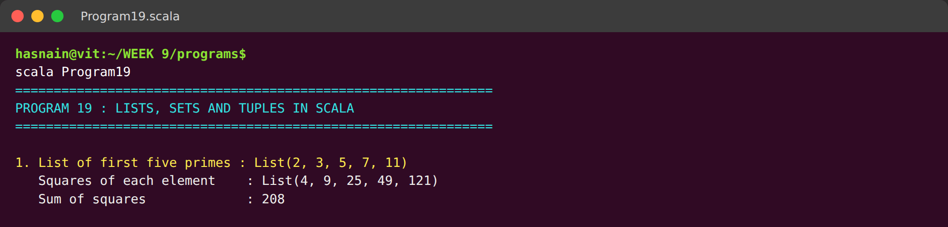  Fig. 2.1: Terminal execution showing the list of prime numbers, the squared list produced by the user-defined function and the sum of the squares.  The list of five primes is printed, followed by the squared list produced by the mapping function and the sum of those squares, so the transformation applied to every element is visible in one place.
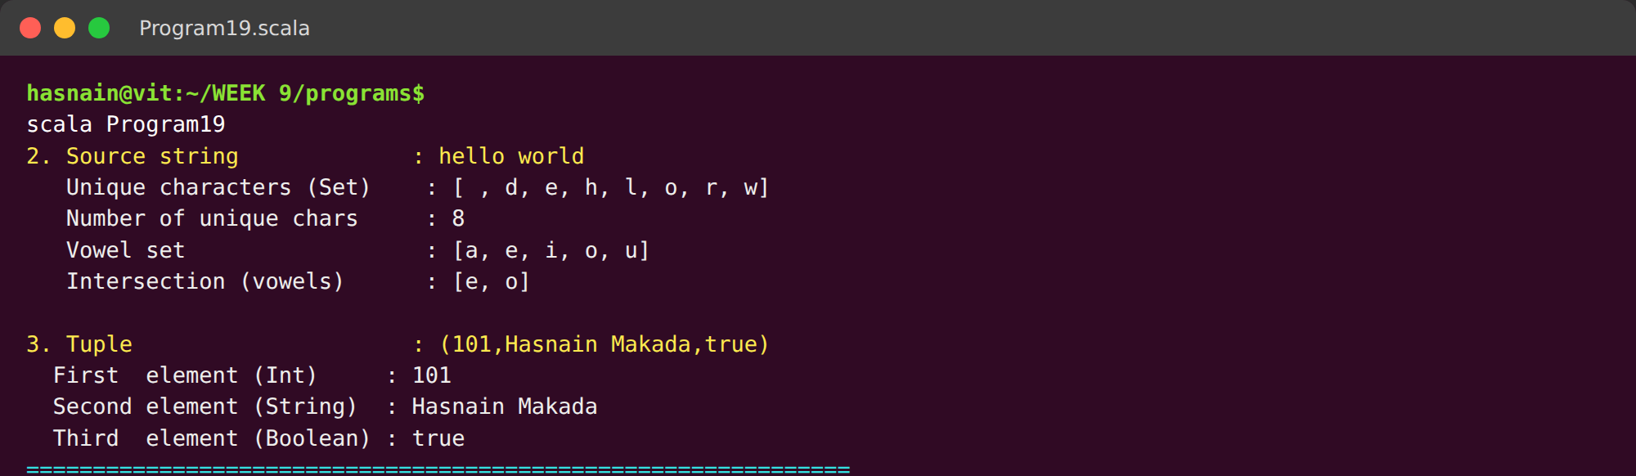
Fig. 2.2: Unique characters extracted from the string, the vowel intersection and the three components of the tuple printed individually.
Converting the string to a set removes the repeated letters and leaves eight unique characters. Intersecting that set with the vowel set returns only e and o, and the tuple is then printed whole before each of its three components is echoed individually.
Conclusions | A list of the first five prime numbers was created and the mapping function returned the squared list (4, 9, 25, 49, 121) with a total of 208. Converting the string hello world into a set removed all duplicate letters and left eight unique characters, and the intersection with the vowel set produced {e, o}. The three-element tuple was created and each component was accessed and printed individually. The experiment showed that Scala lists preserve order, sets guarantee uniqueness and tuples group heterogeneous values without a dedicated class.
References | 1. Scala List documentation: https://www.scala-lang.org/api/current/scala/collection/immutable/List.html  2. Scala Set documentation: https://www.scala-lang.org/api/current/scala/collection/immutable/Set.html  3. Scala Tuples guide: https://docs.scala-lang.org/tour/tuples.html  4. Python program (GitHub link): https://github.com/hasnainmakada-99/Data-Science-Codes/blob/main/WEEK%209/programs/Program19_ListsSetsTuples.scala

Title | HashMaps: Handling Collisions and Resolving Conflicts
Problem Statement | Create a HashMap with keys representing student names and values representing their grades, then insert multiple entries including a duplicate key with a different grade. Write a function to merge two HashMaps, resolving conflicts by taking the higher grade. Finally, write a function to handle collisions by chaining, using lists to store multiple values for a single key.
Objectives | • To create and update a mutable HashMap of student names and grades.  • To observe how a duplicate key overwrites the previously stored value.  • To merge two HashMaps while resolving key conflicts deterministically.  • To implement separate chaining so colliding keys share a bucket.  • To explain the role of the hash function in distributing keys.
Dataset URL Link / File | No external dataset is required. All records are declared inside the program: student names paired with integer grades, plus a second set of six names used to force collisions across four buckets.
Functions Details | Sl. No. | Function | Package | Description of function
Functions Details | 1 | mutable.HashMap() | Scala | Creates a mutable hash table keyed by student name.
Functions Details | 2 | += (key -> value) | Scala | Inserts a new entry or overwrites an existing key.
Functions Details | 3 | get() | Scala | Returns the value for a key wrapped in an Option.
Functions Details | 4 | match / Some / None | Scala | Selects the conflict-resolution branch for a key.
Functions Details | 5 | ++= (collection) | Scala | Copies all entries of one map into another.
Functions Details | 6 | toSeq.sorted | Scala | Orders entries so the map prints deterministically.
Functions Details | 7 | hashCode | Scala | Produces the integer hash used to choose a bucket.
Functions Details | 8 | abs / % (modulus) | Scala | Maps the hash onto a valid bucket index.
Functions Details | 9 | Array.fill() | Scala | Creates the fixed array of bucket chains.
Functions Details | 10 | List / :: (cons) | Scala | Stores several colliding entries in one bucket chain.
Functions Details | 11 | collect() | Scala | Extracts all values that match a key inside a chain.
Functions Details | 12 | foreach / for | Scala | Traverses the bucket array to print occupied buckets.
Steps/ Process/ Procedure/ Algorithm/ Flowchart/ Model | 1. Create a mutable HashMap with three student names and their grades.  2. Insert two more students, then insert an existing key with a different grade.  3. Observe that the duplicate key replaces the earlier grade.  4. Define mergeTakingHigher() that copies the first map into a new map.  5. For every key of the second map keep the larger of the two grades.  6. Print both input maps and the merged map to show resolved conflicts.  7. Define a ChainedHashMap class with a fixed number of buckets.  8. Compute the bucket index as |key.hashCode| % bucketCount.  9. Insert six names so several of them land in the same bucket.  10. Print the non-empty buckets to show the chains built by separate chaining.
Program | // Program 20 - HashMaps: collisions and conflict resolution  // Week 11 | 24-09-2026 | Exercise Program  import scala.collection.mutable  // A HashMap that resolves collisions by separate chaining with lists  class ChainedHashMap(bucketCount: Int) {  private val table: Array[List[(String, Int)]] = Array.fill(bucketCount)(List.empty[(String, Int)])  // Hash function that maps a key to a bucket index  private def bucketIndex(key: String): Int = math.abs(key.hashCode) % bucketCount  // Insert a key-value pair, prepending it to the bucket chain  def put(key: String, grade: Int): Unit = {  val index = bucketIndex(key)  table(index) = (key, grade) :: table(index)  }  // Look up every value stored under a key (a chain may hold several)  def get(key: String): List[Int] =  table(bucketIndex(key)).collect { case (k, v) if k == key => v }  // Show the non-empty buckets, proving that chaining holds the collisions  def display(): Unit = {  println(" Bucket | Chain (key -> grade)")  println(" -------+---------------------")  for (index <- table.indices; if table(index).nonEmpty) {  val chain = table(index).reverse.map { case (k, v) => k + " -> " + v }.mkString(" , ")  println(" " + index + " | " + chain)  }  }  }  object Program20 {  // (a) Merge two HashMaps, resolving conflicts by keeping the higher grade  def mergeTakingHigher(first: mutable.HashMap[String, Int],  second: mutable.HashMap[String, Int]): mutable.HashMap[String, Int] = {  val merged = mutable.HashMap[String, Int]()  merged ++= first  for ((name, grade) <- second) {  merged.get(name) match {  case Some(existing) => if (grade > existing) merged(name) = grade  case None => merged(name) = grade  }  }  merged  }  // (b) Handle collisions by chaining when many keys land in one bucket  def demonstrateChaining(): Unit = {  val chained = new ChainedHashMap(4)  val entries = List("Amit" -> 78, "Neha" -> 85, "Rahul" -> 66, "Sara" -> 92,  "Vikram" -> 74, "Zoya" -> 88)  for ((name, grade) <- entries) chained.put(name, grade)  println(" Hash function : index = |key.hashCode| % 4")  for ((name, _) <- entries) {  println(" " + name + " -> bucket " + (math.abs(name.hashCode) % 4))  }  println()  chained.display()  }  def main(args: Array[String]): Unit = {  println("=" * 62)  println("PROGRAM 20 : HASHMAPS - COLLISIONS AND CONFLICT RESOLUTION")  println("=" * 62)  // 1. Create a HashMap of student names and grades  val grades = mutable.HashMap(  "Hasnain" -> 88,  "Amit" -> 76,  "Neha" -> 91  )  println("\n1. Initial HashMap : " + grades.toSeq.sorted.mkString("{", ", ", "}"))  // 2. Insert multiple entries, including a duplicate key with a different grade  grades += ("Rahul" -> 69)  grades += ("Sara" -> 95)  grades += ("Hasnain" -> 93)  println(" After inserts + duplicate : " + grades.toSeq.sorted.mkString("{", ", ", "}"))  println(" Note: the duplicate key Hasnain replaced 88 with " + grades("Hasnain"))  // 3. Merge two HashMaps, resolving conflicts by taking the higher grade  val sectionA = mutable.HashMap("Hasnain" -> 93, "Amit" -> 76, "Zoya" -> 81)  val sectionB = mutable.HashMap("Hasnain" -> 85, "Zoya" -> 90, "Vikram" -> 74)  val merged = mergeTakingHigher(sectionA, sectionB)  println("\n2. Section A : " + sectionA.toSeq.sorted.mkString("{", ", ", "}"))  println(" Section B : " + sectionB.toSeq.sorted.mkString("{", ", ", "}"))  println(" Merged (higher grade wins): " + merged.toSeq.sorted.mkString("{", ", ", "}"))  println(" Hasnain 93 vs 85 -> " + merged("Hasnain") + " | Zoya 81 vs 90 -> " + merged("Zoya"))  // 4. Collision handling by chaining  println("\n3. Collision handling by separate chaining:")  demonstrateChaining()  println("=" * 62)  }  }
Output Snapshots With Explanation/ Observations | 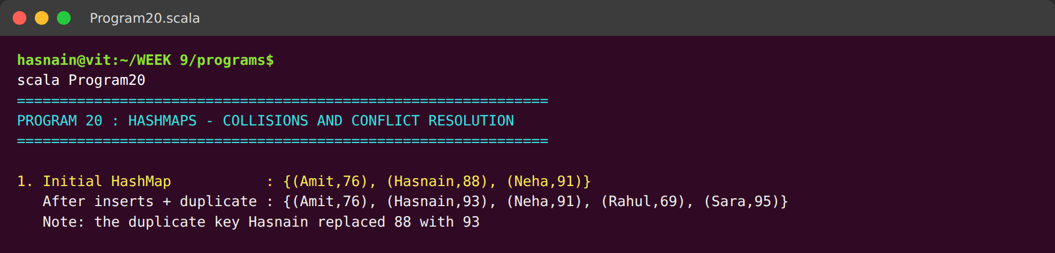  Fig. 3.1: Terminal execution showing the initial HashMap, insertion of new entries, the duplicate-key overwrite and the merge of two HashMaps taking the higher grade.  The initial map holds three students. After the inserts the duplicate key Hasnain replaces the earlier grade of 88 with 93, which shows that a HashMap keeps one value per key. The merged map then resolves the overlapping names by keeping the higher grade.
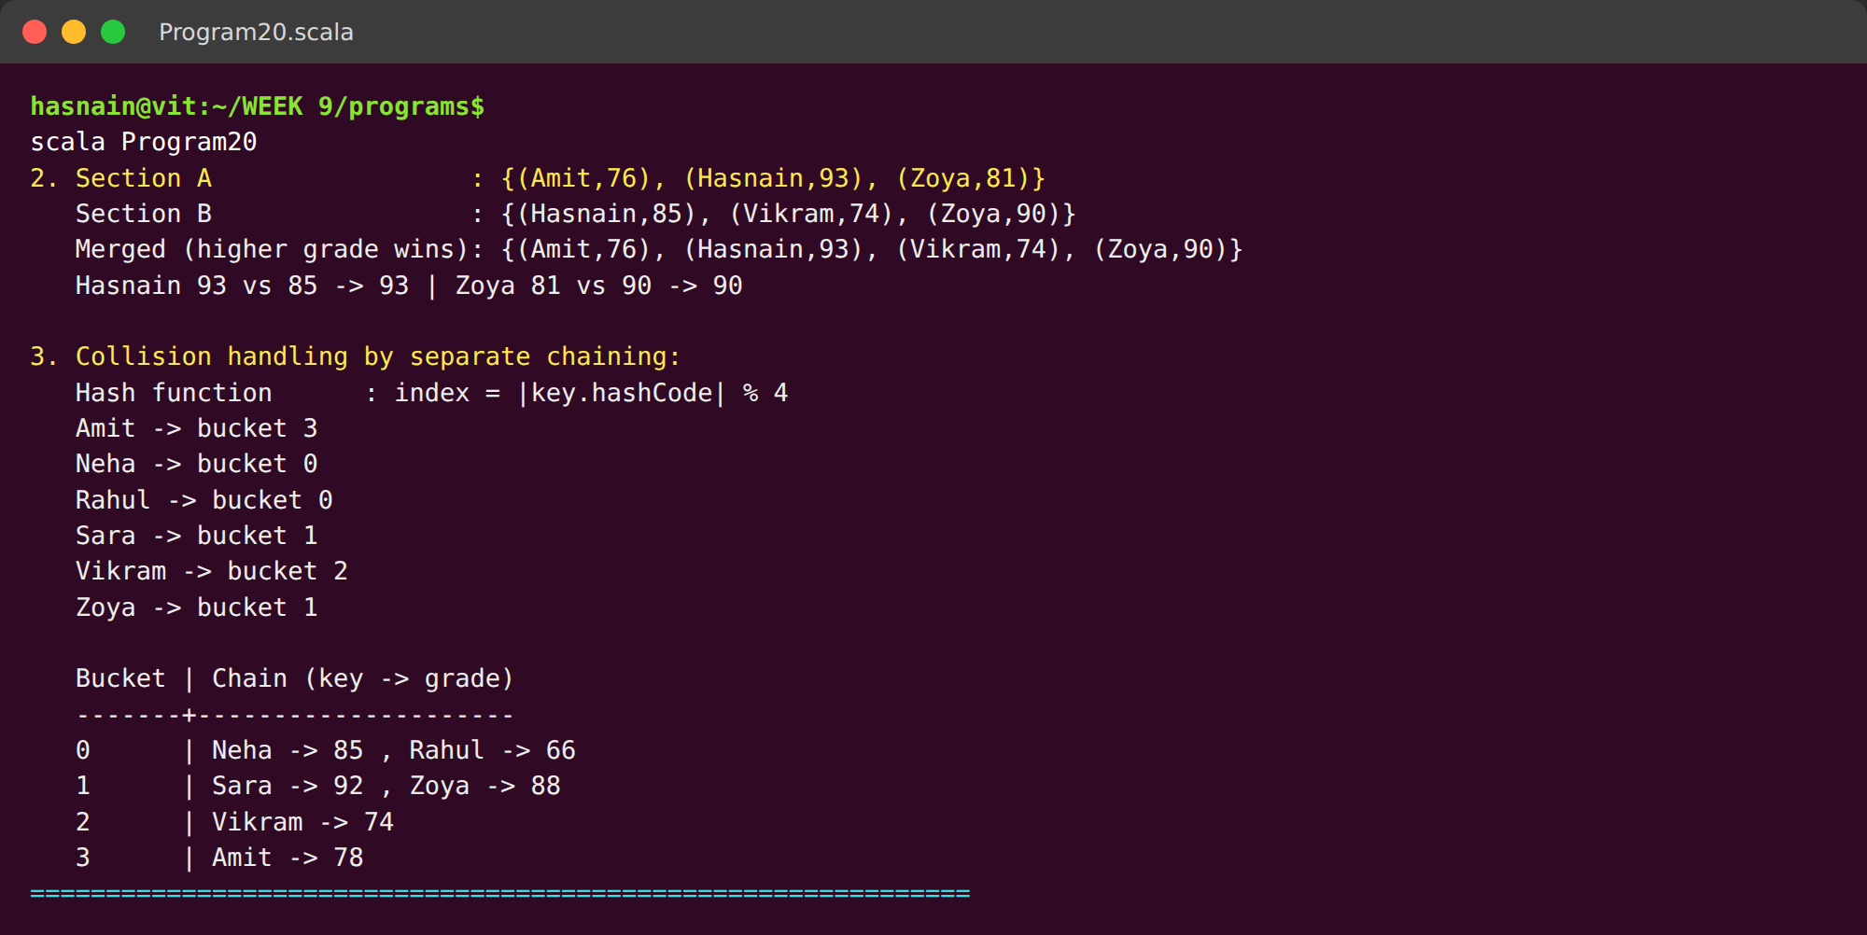
Fig. 3.2: Bucket assignment produced by the hash function and the non-empty buckets showing separate chaining for colliding keys.
The hash function assigns every name to one of four buckets, and two pairs of names land in the same bucket. The bucket table printed underneath lists both entries in each of those chains, so no record is lost even though two keys share an index.
Conclusions | The initial HashMap stored three students and the duplicate insertion for Hasnain replaced the earlier grade of 88 with 93, confirming that a HashMap allows only one value per key. Merging two HashMaps with the higher-grade rule produced a combined map in which Hasnain kept 93 and Zoya was upgraded from 81 to 90. The chained implementation placed six keys into four buckets, with bucket 0 holding Neha and Rahul and bucket 1 holding Sara and Zoya, so no entry was lost even though the hash function assigned two keys to the same index.
References | 1. Scala HashMap documentation: https://www.scala-lang.org/api/current/scala/collection/mutable/HashMap.html  2. Hash table collision resolution: https://en.wikipedia.org/wiki/Hash_table#Collision_resolution  3. Class lecture: Maps and HashMaps in Scala.  4. Python program (GitHub link): https://github.com/hasnainmakada-99/Data-Science-Codes/blob/main/WEEK%209/programs/Program20_HashMapCollisions.scala

Title | Advanced Functional Combinators in Scala
Problem Statement | Create a list of integers from 1 to 10, then use filter to create a new list with only even numbers. Use map to create a new list where each element is multiplied by 3. Use flatMap to create a list of tuples where each integer is paired with its square. Finally, use foldLeft to calculate the product of all elements in the list.
Objectives | • To apply filter, map and flatMap to an immutable list of integers.  • To distinguish flatMap from map by the shape of the returned collection.  • To reduce a collection to a single value with foldLeft.  • To chain several combinators into one readable transformation pipeline.  • To compare each combinator result against known values.
Dataset URL Link / File | No external dataset is required. The source collection is the list of integers from 1 to 10 generated with (1 to 10).toList.
Functions Details | Sl. No. | Function | Package | Description of function
Functions Details | 1 | (1 to 10).toList | Scala | Builds the source list of ten integers.
Functions Details | 2 | filter() | Scala | Keeps only the elements that satisfy a predicate.
Functions Details | 3 | map() | Scala | Transforms every element, preserving the collection length.
Functions Details | 4 | flatMap() | Scala | Transforms each element and flattens results into one list.
Functions Details | 5 | foldLeft() | Scala | Reduces the list left to right using an accumulator.
Functions Details | 6 | product | Scala | Multiplies all elements, used to verify foldLeft.
Functions Details | 7 | sum | Scala | Adds all elements, used to total the mapped list.
Functions Details | 8 | length | Scala | Counts the elements produced by a combinator.
Functions Details | 9 | mkString() | Scala | Joins the resulting elements into one display string.
Functions Details | 10 | List((n, n*n)) | Scala | Wraps each pair so flatMap can flatten it.
Functions Details | 11 | println() | Scala | Writes one formatted line of text to the console.
Functions Details | 12 | main() | Scala | Entry point that executes the program.
Steps/ Process/ Procedure/ Algorithm/ Flowchart/ Model | 1. Build the source list of the integers 1 to 10.  2. Apply filter with the predicate n % 2 == 0 to keep the even numbers.  3. Apply map with the function n * 3 to triple every element.  4. Apply flatMap so each integer is paired with its square.  5. Apply foldLeft with seed 1 and multiplication to obtain 10 factorial.  6. Verify the foldLeft result against the built-in product of the list.  7. Chain filter, map and foldLeft into a single transformation pipeline.  8. Print a summary of how many elements each combinator produced.
Program | // Program 21 - Advanced functional combinators  // Week 12 | 08-10-2026 | Exercise Program  object Program21 {  def main(args: Array[String]): Unit = {  println("=" * 62)  println("PROGRAM 21 : ADVANCED FUNCTIONAL COMBINATORS")  println("=" * 62)  val numbers = (1 to 10).toList  println("\n1. Source list (1 to 10) : " + numbers.mkString("[", ", ", "]"))  // 2. filter - keep only the even numbers  val evens = numbers.filter(n => n % 2 == 0)  println("\n2. filter(n % 2 == 0) : " + evens.mkString("[", ", ", "]"))  println(" Count of even numbers : " + evens.length)  // 3. map - multiply every element by 3  val tripled = numbers.map(n => n * 3)  println("\n3. map(n => n * 3) : " + tripled.mkString("[", ", ", "]"))  println(" Sum after mapping : " + tripled.sum)  // 4. flatMap - pair every integer with its square  val pairs = numbers.flatMap(n => List((n, n * n)))  println("\n4. flatMap(n => (n, n*n)) :")  println(" " + pairs.mkString("[", ", ", "]"))  println(" Number of pairs produced : " + pairs.length)  // 5. foldLeft - product of all elements  val product = numbers.foldLeft(1)((accumulator, n) => accumulator * n)  println("\n5. foldLeft(1)(_ * _) : " + product)  println(" Verification (10!) : " + (1 to 10).product +  " , match = " + (product == (1 to 10).product))  // 6. Combined pipeline using several combinators together  val pipeline = numbers  .filter(n => n % 2 == 0)  .map(n => n * 3)  .foldLeft(0)((accumulator, n) => accumulator + n)  println("\n6. Combined pipeline")  println(" evens -> x3 -> sum : " + pipeline)  println("\n7. Summary of combinator results")  println(" filter -> " + evens.length + " elements")  println(" map -> " + tripled.length + " elements")  println(" flatMap -> " + pairs.length + " elements")  println(" foldLeft -> single value " + product)  println("=" * 62)  }  }
Output Snapshots With Explanation/ Observations | 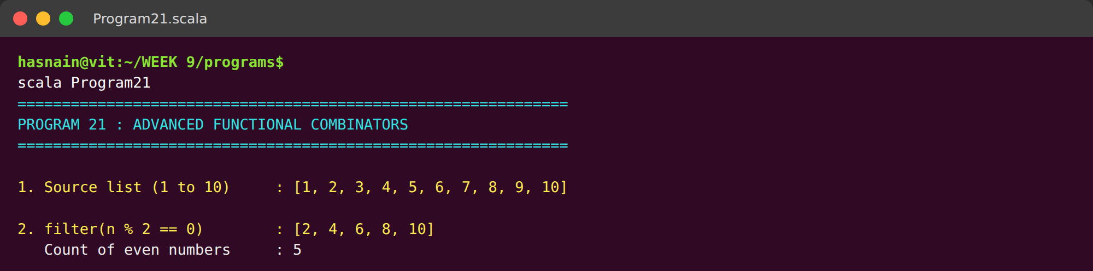  Fig. 4.1: Terminal execution showing the source list, the filtered even numbers, the tripled list and the flatMap pairs generated from the input list.  The source list 1 to 10 is shown, followed by the five even numbers returned by filter and the ten tripled values returned by map. The flatMap block pairs every integer with its square and flattens the pairs into a single list.
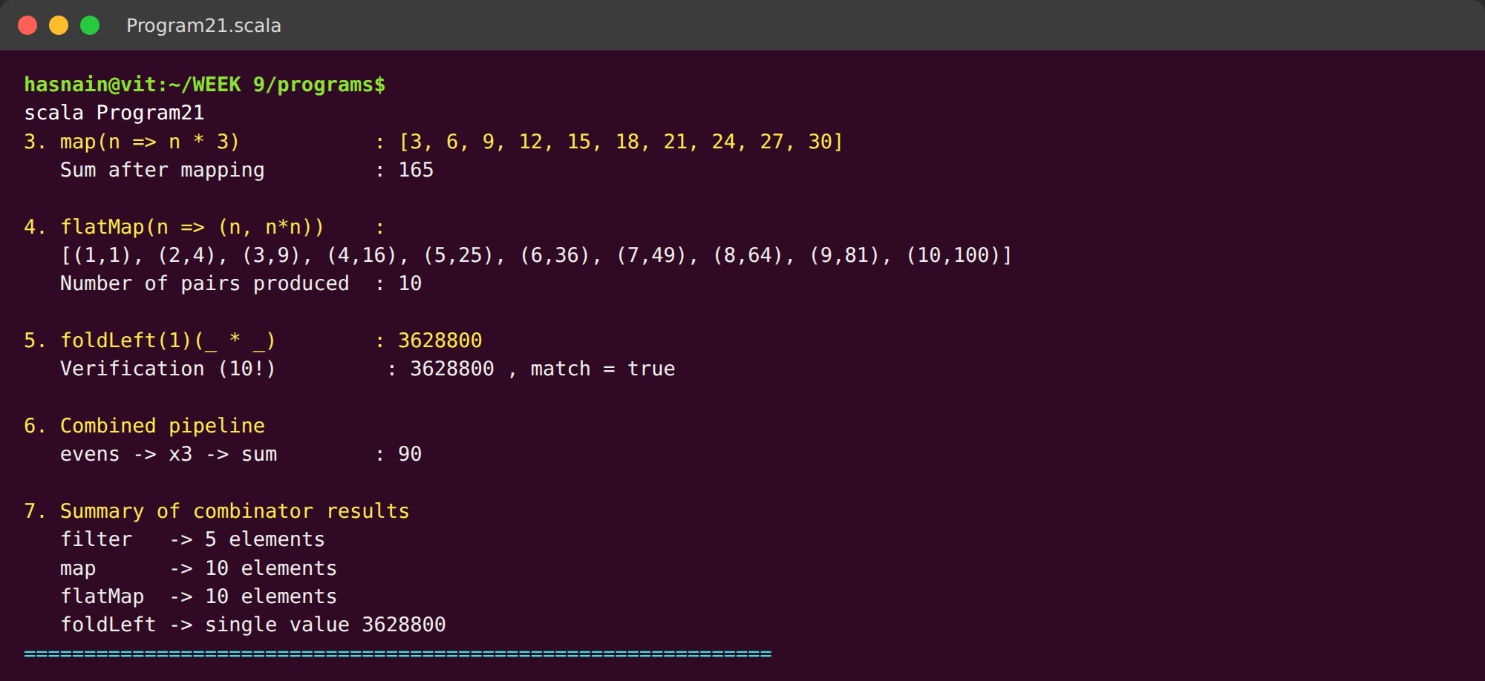
Fig. 4.2: foldLeft product with its verification against the built-in product, the combined pipeline result and the summary of combinator outputs.
foldLeft reduces the list to 3628800, and the verification line confirms that this equals the built-in product of 1 to 10. The combined pipeline then applies filter, map and foldLeft in one expression to give 90, and the summary counts how many elements each combinator produced.
Conclusions | Applying filter to the list 1 to 10 returned the five even numbers (2, 4, 6, 8, 10), while map with multiplication by three produced a list of the same length containing (3, 6, 9, ..., 30). flatMap paired every integer with its square and flattened the pairs into a single list of ten tuples, and foldLeft returned 3628800, which matches the built-in product and confirms 10 factorial. The combined pipeline of filter, map and foldLeft produced 90 in a single expression, showing that functional combinators can replace explicit loops with shorter and more declarative code.
References | 1. Scala collections operations: https://docs.scala-lang.org/overviews/collections/operations.html  2. Scala tour: anonymous function syntax: https://docs.scala-lang.org/tour/anonymous-function-syntax.html  3. Class lecture: Functional combinators in Scala.  4. Python program (GitHub link): https://github.com/hasnainmakada-99/Data-Science-Codes/blob/main/WEEK%209/programs/Program21_FunctionalCombinators.scala

